Top 9 Things You Didn't Know About America's Power Grid

This article is part of the Energy.gov series highlighting the “Top Things You Didn’t Know About…” Be sure to check back for more entries soon.

9. Ever wonder how electricity gets to your home? It’s delivered through the grid -- a complex network of power plants and transformers connected by more than 450,000 miles of high-voltage transmission lines. The basic process: Electric power is generated at power plants and then moved by transmission lines to substations. A local distribution system of smaller, lower-voltage transmission lines moves power from substations to you, the customer. Watch an animated video on [how the grid works](http://www.youtube.com/watch?v=1dZjohZPIqE#t=128).

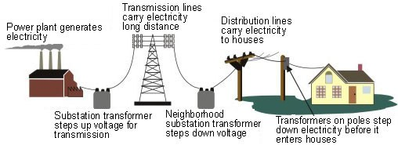

[eia.gov](http://www.eia.gov/energyexplained/index.cfm?page=electricity_delivery)

·

[2 years ago](http://www.eia.gov/energyexplained/images/transmission.jpg)

8. Thomas Edison launched the first commercial power grid, [The Pearl Street Station](http://www.ieeeghn.org/wiki/index.php/Pearl_Street_Station), in lower Manhattan in 1882. The offices of The New York Times, one of Edison’s earliest electricity customers, reported lighting provided by Pearl Street was “soft, mellow, grateful to the eye.”

[Pearl Street Station](http://www.ieeeghn.org/wiki/index.php/Pearl_Street_Station)

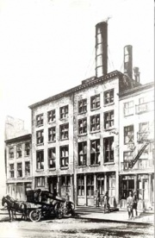

From GHN Pearl Street Station With the opening of the Pearl Street station in lower Manhattan at 3 o'clock in the afternoon on 4 September



[Ieeeghn](http://www.ieeeghn.org)

7. [America’s electric grid](http://www.eia.gov/energy_in_brief/article/power_grid.cfm) is actually comprised of three smaller grids, called interconnections, that move electricity around the country. The Eastern Interconnection operates in states east of the Rocky Mountains, The Western Interconnection covers the Pacific Ocean to the Rocky Mountain states, and the smallest -- the Texas Interconnected system -- covers most of Texas, as displayed in the map below:

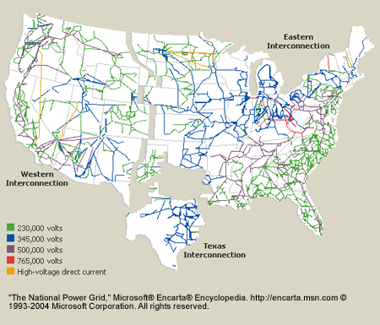

[eia.gov](http://www.eia.gov/energy_in_brief/article/power_grid.cfm)

·

[2 years ago](http://www.eia.gov/energy_in_brief/images/maps/natl_power_grid.gif)

6. The electric grid is an engineering marvel but its aging infrastructure requires extensive upgrades to effectively meet the nation’s energy demands. Through the Recovery Act, the Department invested about $4.5 billion in grid modernization to enhance the reliability of the nation’s grid. Since 2010, these investments have been used to deploy a wide range of advanced devices, including more than 10,000 [automated capacitors](http://www.smartgrid.gov/glossary/term/73), over 7,000 [automated feeder switches](http://www.smartgrid.gov/glossary/term/315) and approximately 15.5 million smart meters. See a map of the Recovery Act-funded Smart Grid Investment Grant and Smart Grid Demonstration projects at [smartgrid.gov](http://smartgrid.gov):

[SmartGrid.gov:](http://www.smartgrid.gov/recovery_act/project_information)

The American Recovery and Reinvestment Act of 2009 (Recovery Act) provides the U.S. Department of Energy with $4.5 billion to modernize t...



[Smartgrid](http://www.smartgrid.gov)

5. What is the distinction between grid reliability and resiliency? A more reliable grid is one with fewer and shorter power interruptions. A more resilient grid is one better prepared to recover from adverse events like severe weather.

4. Severe weather is the number one cause of power outages in the United States, costing the economy between [$18 and $33 billion every year](http://energy.gov/sites/prod/files/2013/08/f2/Grid%20Resiliency%20Report_FINAL.pdf) in lost output and wages, spoiled inventory, delayed production and damage to grid infrastructure.

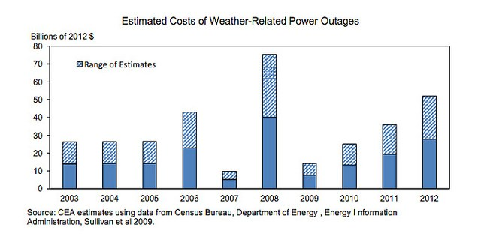

Screen Shot 2013-09-20 at 6.43.50 AM

[ENERGY.GOV](http://www.flickr.com/photos/37916456@N02)

·

[2 years ago](http://www.flickr.com/photos/37916456@N02/9834496305)

The number of outages caused by severe weather is expected to rise as climate change increases the frequency and intensity of extreme weather events. Preparing for the challenges posed by climate change requires investment in 21st century technology that will increase the resiliency and reliability of the grid.

[Protecting the Electric Grid From Increasingly Severe Weather Due to Climate Change | The White House](http://www.whitehouse.gov/blog/2013/08/12/protecting-electric-grid-increasingly-severe-weather-due-climate-change)



A new report from the White House Council of Economic Advisers and the Energy Department evaluates the economic cost of power outages and...



[WhiteHouse.gov](http://www.whitehouse.gov)

3. One of the key solutions for a more resilient and reliable grid is [synchro phaser technology](http://www.smartgrid.gov/sites/default/files/doc/files/Synchrophasor%20Report%2008%2009%202013%20DOE%20(2)%20version_0.pdf). These mailbox-size devices monitor the health of the grid at frequencies not previously possible, reporting data 30 times per second. This enhanced visibility into grid conditions helps grid operators identify and respond to deteriorating or abnormal conditions more quickly, reduce power outages and help with the integration of more renewable sources of energy into the grid. To date, nearly 900 of these devices have deployed as a result of Recovery Act investments.

2. Microgrids, which are localized grids that are normally connected to the more traditional electric grid but can disconnect to operate autonomously, are another way in which the reliability and resiliency of the grid can be improved. Microgrids use advanced smart grid technologies and the integration of distributed energy resources such as backup generators, solar panels and storage. Because they can operate independently of the grid during outages, microgrids are typically used to provide reliable power during extreme weather events. As part of the Obama Administration’s commitment to rebuild communities affected by Superstorm Sandy, the Department is [partnering with the State of New Jersey](http://energy.gov/articles/energy-department-partners-state-new-jersey-study-ways-improve-reliability-new-jersey-s) and other organizations to examine the use of microgrids to help keep the power on during future extreme weather events.

[Energy Department Partners with State of New Jersey to Study Ways to Improve the Reliability of New Jersey's Transit System in Aftermath of Superstorm Sandy](http://energy.gov/articles/energy-department-partners-state-new-jersey-study-ways-improve-reliability-new-jersey-s)



You are here " Energy Department Partners with State of New Jersey to Study Ways to Improve the Reliability of New Jersey's Transit System



[Energy](http://energy.gov)

* + [Add to story or collection](http://storify.com/ENERGY/9-things-you-didn-t-know-about-the-grid/embed?##)
  + [Share on Twitter](http://storify.com/ENERGY/9-things-you-didn-t-know-about-the-grid/embed?##)
  + [Share on Facebook](http://storify.com/ENERGY/9-things-you-didn-t-know-about-the-grid/embed?##)
  + [Share on Google+](http://storify.com/ENERGY/9-things-you-didn-t-know-about-the-grid/embed?##)
  + [Share on LinkedIn](http://storify.com/ENERGY/9-things-you-didn-t-know-about-the-grid/embed?##)
  + [Share by email](http://storify.com/ENERGY/9-things-you-didn-t-know-about-the-grid/embed?##)

1. Since 2010, the Energy Department has invested more than $100 million to advance a resilient grid infrastructure that can survive a cyber incident while sustaining critical functions. [The Department’s cybersecurity work](http://energy.gov/oe/downloads/roadmap-achieve-energy-delivery-systems-cybersecurity-2011) involves ongoing collaboration with a number of public and private partners including the Department of Defense, the Department of Homeland Security, the National Institute of Standards and Technology, the intelligence community, private industry and energy-sector stakeholders.